Particle-Like states

in chiral magnets

Nikolai S. Kiselev

Institute for Advanced Simulation, Forschungszentrum Jülich, D-52425 Jülich, Germany

e-mail: n.kiselev@fz-juelich.de

An explosion of activity in the field of particle-like localized states in chiral magnets is associated with the perspectives of their usage in recently proposed concept of magnetic solid-state data storage device - skyrmion racetrack memory [1]. Skyrmions are vortex-like magnetic textures with particle-like properties, which have been predicted theoretically more than twenty years ago [2], but have been discovered experimentally only recently. It was assumed that skyrmions are unique objects, which can be stabilized in this type of materials. Recently we made a prediction for another type of a thermodynamically stable magnetic particle-like object, which appears at interfaces, and surfaces of isotropic chiral magnets [3]. Because of the essential chirality of such a state and its localization close to the surface with the finite penetration depth, like a fishing bobber at a water surface, we use term chiral bobber to refer to this object. The chiral bobber constitutes a new class of particles – the hybrid particles composed of a smooth magnetization field and a magnetic singularity (Bloch point).
In this talk I will make a short historical overview of chiral magnetic skyrmions and present comprehensive theoretical analysis for the range of existence of new objects. I discuss the mechanism of their stabilization and perspectives of their usage in spintronics. In particular, we have shown that in a wide range of parameters magnetic skyrmions and chiral bobbers may coexist. This fact gives rise to a new concept of racetrack memory where two types of localized states play a role of two types of data bit carriers and the information can be encoded exclusively by the sequence of skyrmions and chiral bobbers in the chain moving along the guiding nanostripes.
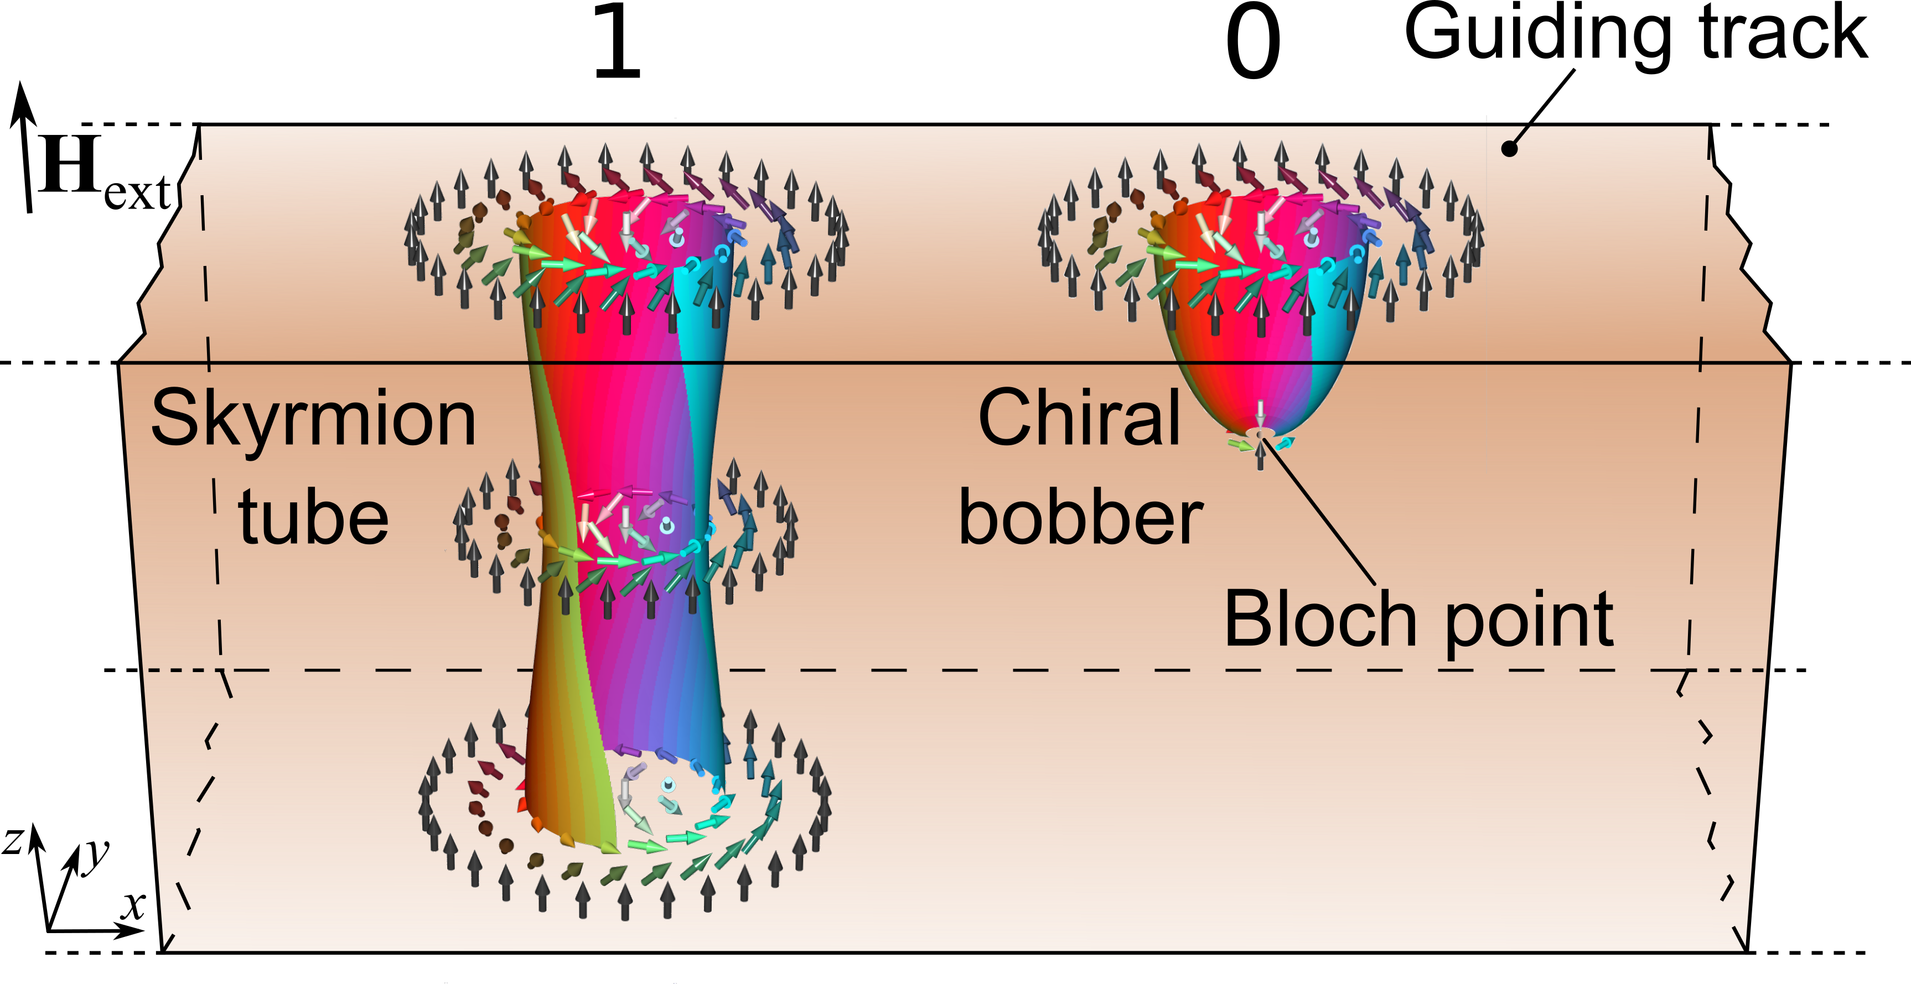
Figure 1. Schematic representation for a small part of the long stripe of chiral magnet playing a role of guiding track for the chain of chiral skyrmions and bobbers. The color of the vectors and corresponding isosurfaces is defined by in-plain component of magnetic moment according to the standard color wheel. In the guiding nanostripe the binary data is encoded by the sequence of skyrmions and chiral bobbers representing binary state: 1 or 0 respectively.

1. A. Fert et al., Nat. Nanotech. 8, 152 (2013).
2. N.A. Bogdanov & D.A. Yablonskii Sov. Phys.JETP 68, 101 (1989).
3. F. N. Rybakov et al. Phys. Rev. Lett. 115, 117201 (2015).

